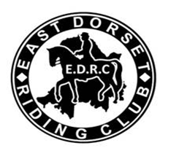
MEMBERS ONLY!

SOCIAL RIDE. NEW FOREST

MEMBER’S NAME_

MEMBER’S HORSE_

MEMBERSHIP NUMBER_

You will be required to sign a disclaimer, stating that should you fall off, you will not be able to claim from the EDRC club for either you or your horse/pony.

Please forward BACS payment to EDRC, Sort Code: 40-46-37. Account no: 51496581

Make sure you put the date down as reference on BACS and email to: eastdorsetridingclub@gmail.com

